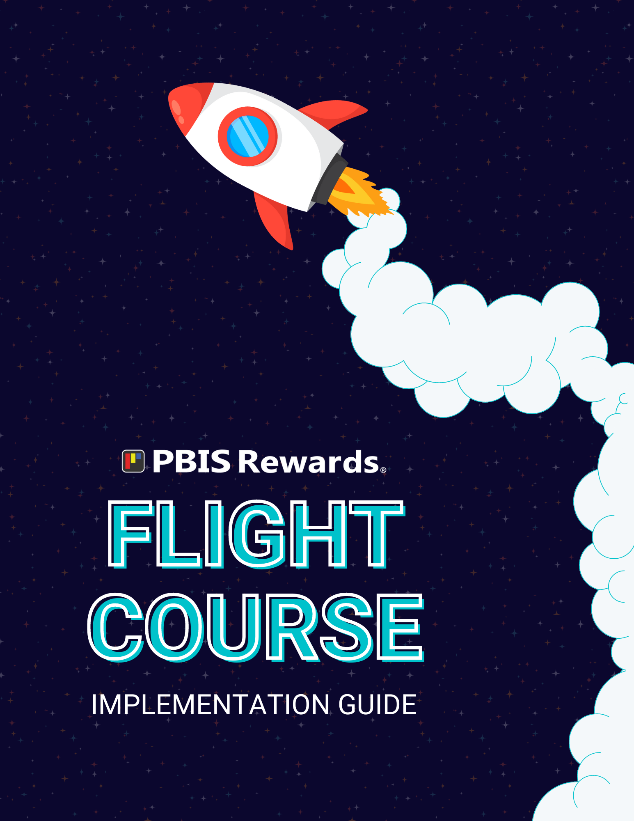

A note about this guide. . .
“There is only one way to eat an elephant: a bite at a time.” - Desmond Tutu
Welcome to your PBIS Rewards journey! We are thrilled that you have decided to embrace a PBIS mindset on your district or campus! Our team knows exactly how game-changing a well-implemented PBIS program can be for schools, but we also understand that initiating or even maintaining a robust framework can seem overwhelming. With that in mind, we have created this Flight Course Guide to help you get started in this process.
When approaching the incorporation of PBIS and PBIS Rewards into your campus’ daily routine, we have found that those who work step-by-step, or “a bite at a time”, tend to experience a more stable beginning to their foundational process. Because consistency in implementation is the key to success, we wanted to provide educators and staff members with a piece-by-piece guide so that your PBIS team can begin to thoughtfully plan out your school’s implementation plan.
This guide is laid out in the order that we, as trainers, believe is the best way to use PBIS Rewards. We encourage you to pace your work through this guide, one section at a time, and to resist the temptation to ‘power through’. To assist with this, each section includes a space for reflection and notes, allowing leadership to notate future thinking and assess next steps. Following each section, you will also find a bulleted list of topics under the title, “Pause to Assess Your Progress”. These are the major points and ‘big rocks’ to implement from that section. Once those concepts and procedures have been mastered, your team will move onto the next section, and continue growing!

We cannot emphasize enough that PBIS implementation requires a “slow, but steady” mindset. It will take time, but dedication to thoroughly completing each part of this guide, reflecting, and carefully considering your plan for implementing PBIS with fidelity will ultimately lead to success. Are you ready to get started?!

Table of Contents

PBIS Leadership Team Info 3
Rewarding Points 6
Redeeming Ideas 9
ID Cards 21
Teacher Buy-In 23
Final Reflections 29
ARS 29

PBIS Leadership Team Info
Checkpoints to Get Started  Prerequisites before you jump into PBIS Rewards planning. | - PBIS Leadership Team in place  - School-Wide Expectations  - Behavior Matrix in place  - Training on PBIS Foundations to Staff
PBIS Leadership Team Members  - Who is leading the team?  - Do we have a cross-sampling of staff?  - Do we want parents or students to serve on the team? | Position | Name of Staff Member
 | Team Leader
 | Admin. Team Member
 | Teacher
 | Teacher
 | Teacher
 | Staff
 | Staff
 | Student Rep?
 | Parent Rep?
Implementation Schedule  Do you have a plan for rolling out PBIS and PBIS Rewards to all your stakeholders? | Topics |  |  | Proposed Date
 | Pre-planning meeting with PBIS Leadership Team for roll-out
 | Telling the staff about PBIS Rewards (Communication plan!)
 | Faculty Meeting for Staff Buy-In
 | Communication to Auxiliary Staff
 | First day to roll out for school-wide implementation
 | Student Assembly/Information session
 | Parent/Community Roll-out
PBIS Leadership Team  Meeting Schedule  Setting regular meetings to discuss implementation and data is a priority for successful implementation. | Monthly Meeting | Tentative Meeting Date |  |  | Data to Guide  Decision-Making
 | July
 | Aug
 | Sept
 | Oct
 | Nov
 | Dec
 | Jan
 | Feb
 | Mar
 | Apr
 | May
 | June
Notes |  |  | Reflections

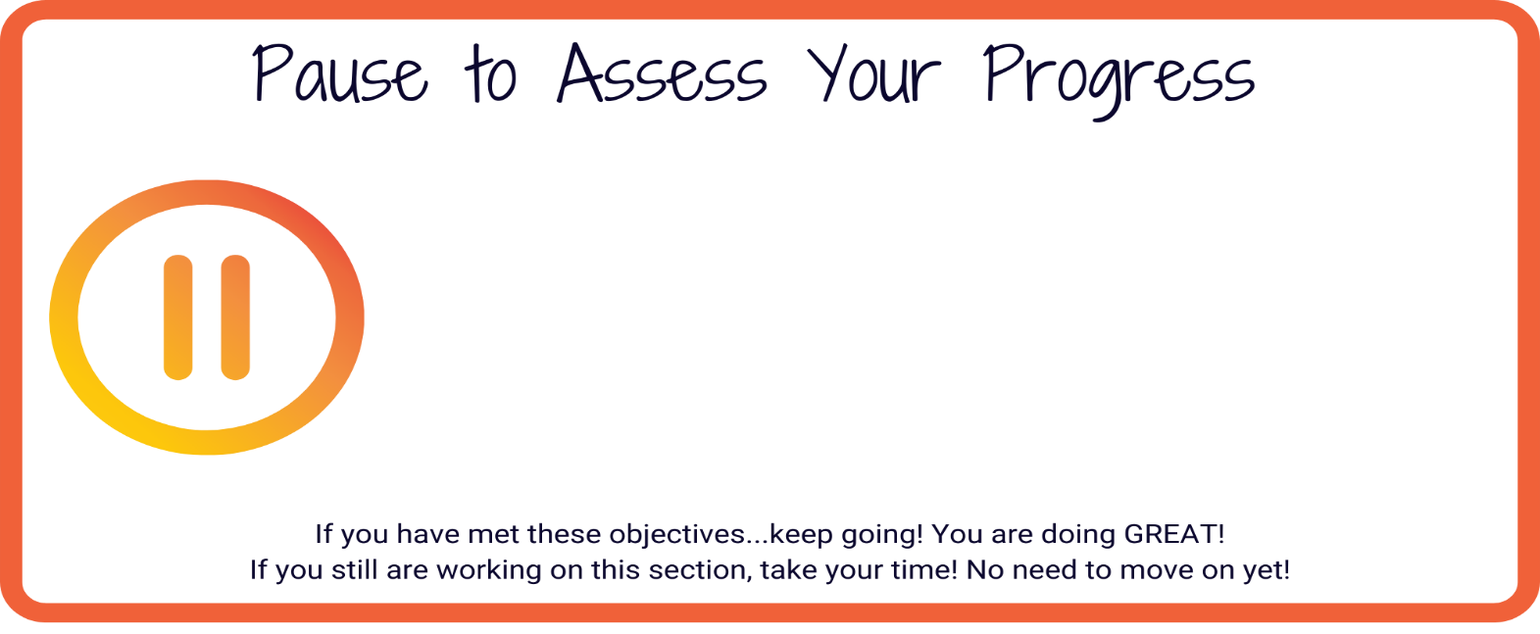
- PBIS Leadership Team is built with staff representation
- PBIS Leadership Team Leader/Coach is a staff member, not Admin.
- Implementation plan for staff is fully planned
- Student and Family Roll Out planned

Rewarding Points

The number of points awarded to students daily will ultimately determine your school’s economy for redeeming.

Setting a daily point goal for classroom and support staff will help keep the fidelity of your economy in place so everyone can participate in your chosen redeeming option equitably.
Are we setting a Daily Point Goal for staff and students? | Staff |  |  |  | Students
 | Yes No |  |  |  | Yes No
What will the Daily Goal Point be?  Support staff should typically have a goal of 50% of classroom staff. Students typically have a goal of 20% of a classroom staff goal. | Classroom  Staff  (Frequent users such as teachers and teacher assistants who have regular interaction with students) | Support  Staff  (Moderate users such as administrators or school counselors who may have less frequent interactions to students) |  |  | Students
What will be your communication plan for each group? | Staff |  |  | Students

Progress Monitoring

Who is going to be responsible for checking on the progress of DPG for staff?

How will this data be shared? (With PBIS Leadership Team and all staff)
Notes |  |  | Reflections

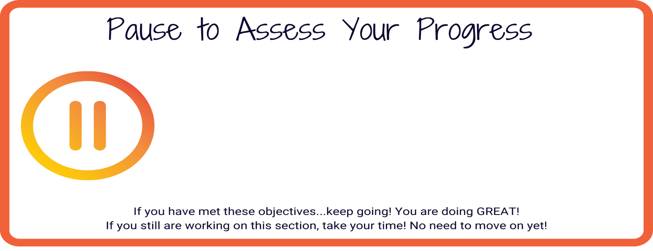
- Daily Point Goals have been established for staff and students
- Daily Point Goals are monitored by PBIS Leadership Team member(s)
- Communication Plan established as Daily Point Goals are adjusted over time

Redeeming Ideas

There are many options to redeem points inside of PBIS Rewards.

Do NOT feel pressure to try them all at once. Explore your options and then pick the right one for YOUR SCHOOL to try first.

Options for Redeeming in PBIS Rewards
Raffles  - Only need 1 item to raffle  - Perfect for a limited budget  - Great for an assembly  - Donated items can be raffled off |  | Events  - Schools already have lot of events happening. This will allow easy crossover!  - 3 different ways to host events  - Can use for entire school or selected grade levels |  |  | Stores  - Inventory is monitored by system with email notifications  - Less pressure for teachers to purchase items out of their own pocket

Raffles
Will we use Raffles? | Yes |  |  | No
Do we want to start with a Redeem or Qualify raffle?  Redeem raffles require students to spend points to enter the raffle. The more points the student spends to enter, the better chance they have of winning.  Qualify raffles DO NOT cost the students any points to enter BUT they must have earned the number of points needed to participate. If the student qualifies then they will automatically have one entry in the raffle by using Auto Register. | Redeem |  |  | Qualify
 | - Students will spend points to enter the raffle.  - The more points the student spends to enter, the better chance they have of winning. |  |  | - These raffles DO NOT cost the students any points to enter BUT they must have earned the number of points needed to participate.  - If the student qualifies then they will automatically have one entry in the raffle by using Auto Register.

What item(s) will we raffle?

Where will we host the raffle?

In person during assembly, virtually, record it and share, privately, and announce winner?

When will we run the raffle?

Who will manage the Raffle?
Notes |  |  | Reflections

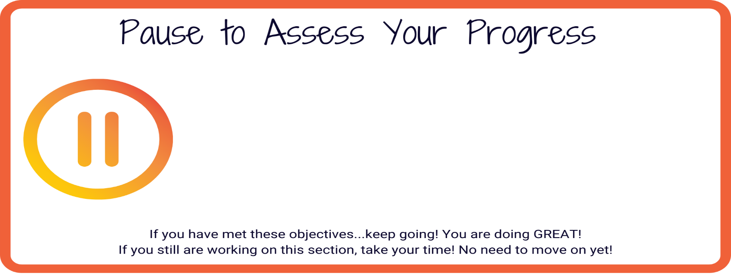
- Select raffles to encourage engagement, then explore other redeeming options as the year progresses.
- What? Where? When? Who? for raffles
Redeeming Ideas

There are many options to redeem points inside of PBIS Rewards.

Do NOT feel pressure to try them all at once. Explore your options and then pick the right one for YOUR SCHOOL to try first.

Options for Redeeming in PBIS Rewards
Raffles  - Only need 1 item to raffle  - Perfect for a limited budget  - Great for an assembly |  | Events  - Schools already have lot of events happening. This will allow easy crossover!  - 3 different ways to host events  - Can use for entire school or selected grade levels |  |  |  | Stores  - Inventory is monitored by system with email notifications  - Less pressure for teachers to purchase items out of their own pocket

Events
Will we use Events? | Yes |  |  |  | No

What events do we currently have scheduled for this year or plan to schedule?
Do we want to start with a Redeem, Qualify, or a Reward event?  Redeem: Students spend points to attend. This type of event will deduct points.  Qualify: Do not deduct points. Students qualify by earning a set amount of points in a specified time period. Points do not have to be saved up; PBIS Rewards will calculate a running total of points earned.  Reward: Attendees earn the specified number of points | Redeem |  |  | Qualify |  |  | Reward

What is the first event we will host?

Cost of event?
Redeem = Deduct points
Qualify = Student met goal over time
Reward = Earn points

Where will we host the event?

In person, virtually, etc.?

When will we host the event?

Who will manage the event?
Notes |  |  | Reflections

- Select events to encourage engagement, then explore other redeeming options as the year progresses.
- What? Where? When? Who? for events
Redeeming Ideas

There are many options to redeem points inside of PBIS Rewards.

Do NOT feel pressure to try them all at once. Explore your options and then pick the right one for YOUR SCHOOL to try first.

Options for Redeeming in PBIS Rewards
Raffles  - Only need 1 item to raffle  - Perfect for a limited budget  - Great for an assembly |  | Events  - Schools already have lot of events happening. This will allow easy crossover!  - 3 different ways to host events  - Can use for entire school or selected grade levels |  |  | Stores  - Inventory is monitored by system with email notifications  - Less pressure for teachers to purchase items out of their own pocket

Stores
Will we use Stores? | Yes |  |  | No

What will be the name of our School Store?

What categories will we use to divide up our store?
Will we have digital and tangible options in our store?  Opportunities for experiences? | Tangible Items |  |  | Virtual Items
 | Opportunities for Experiences

Will we allow student purchasing?
All grades? Specific grades?

This can be changed in Settings menu.

Where will we store the tangible items?

Who will manage the store?
Checking stock, organizing inventory, updating PBIS Rewards

When will the store be open?
Store hours can be set in the Settings menu.

How will you distribute tangible items to students?

Will we be utilizing Cashier Accounts for our store?
Who will give cashiers access?
Notes |  |  | Reflections

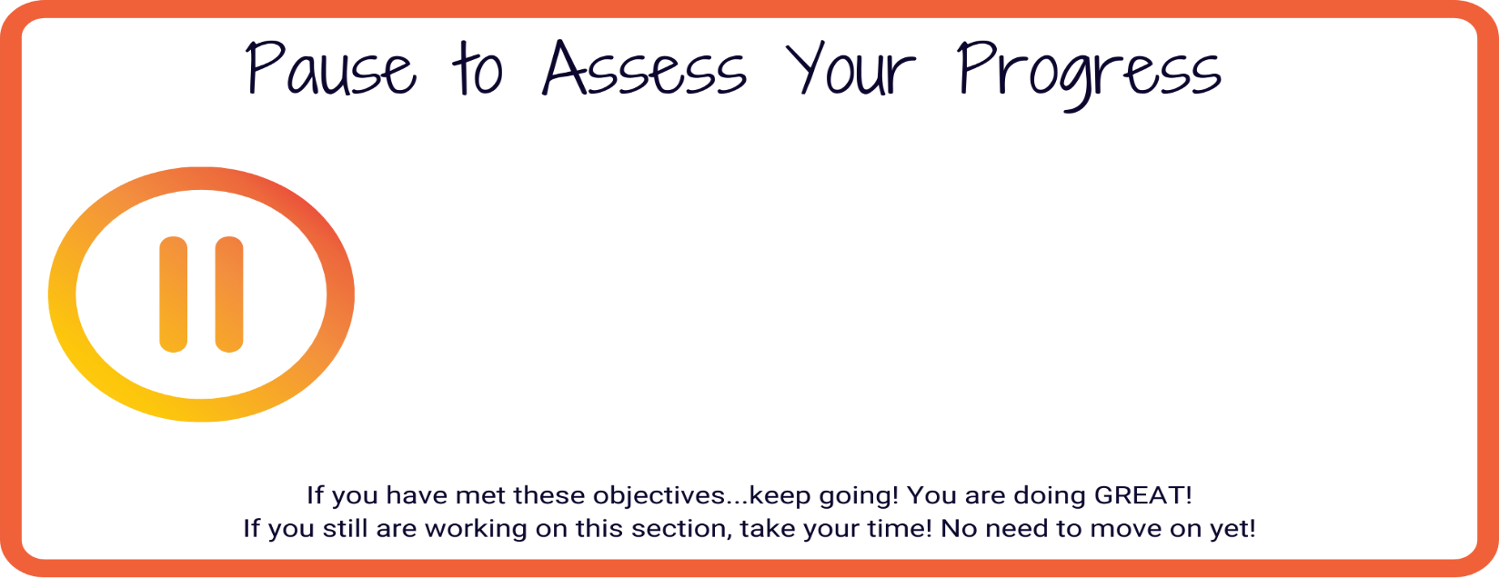
- Select stores to encourage engagement, then explore other redeeming options as the year progresses.
- What? Where? When? How? Who? for stores

ID Cards
Did we order PBIS Rewards ID Cards?  Not sure? Find the ID Card contact in Settings under School Information. | YES |  | NO

Are we printing ID Cards for students to wear?
(If not ordered from PBIS Rewards)

Who is responsible for printing these? How will they be passed out? Will they be collected at the end of the day?

Are we utilizing printed ID Cards/QR Codes anywhere else?
(Various sizes available in PBIS Rewards)

Technology, folders, agenda books, desks, lockers, etc.

What is the process to issue a NEW/REPLACEMENT ID Card?

Do you print off a paper ID Card? Have students purchase a new one from school store, etc.
Notes |  | Reflections

- Determine if students will wear ID badges or if ID Badges/QR Codes will be placed in other locations for use.
- Complete the process for replacing ID Badges

Teacher Buy-In

Teacher Rewards in PBIS Rewards System
Will we use Teacher Rewards this year? | YES |  | NO

When will we roll out Teacher Rewards to the staff?

Since Teacher Rewards applies to ALL STAFF, what is the plan to roll out to non-classroom staff?

Bus drivers, cafeteria workers, custodians, secretaries, etc.

What items will the teachers/staff be able to redeem points for?

Who will be the Admin. that will approve points in Teacher Rewards?

General Teacher Buy-In Planning

What will be the first step to engage staff with PBIS Rewards?
What resources and topics will we share with staff? | Topics |  | Resources

What will the agenda be for professional development/training?

Who will lead the PD?

When will the PD be offered?

How will it be offered?
(In-person, virtually)

What resources do you need to create?

How do we celebrate teachers using PBIS Rewards with fidelity?

What data will we share with staff regularly?

What additional training will your PBIS Leadership Team, Staff, or Admin. need to be successful this year?
Notes |  | Reflections

- Will we use Teacher Rewards?
- Roll out plan for all staff members completed
- Admin. for Teacher Rewards has been established
- Staff members have options to redeem points earned

Final Reflections

What is your #1 goal to accomplish this year?
What are your three next steps to prepare for this goal before school starts? | 1.
 | 2.
 | 3.

Advanced Referral System is a paid add-on
with the PBIS Rewards System.

If your school has this feature enabled, use the next pages to continue your planning.

ARS

Advanced Referral System is a paid add-on with the PBIS Rewards System.
If your school has this feature enabled, use this table to continue your planning.

Check YES or No for the following questions | YES |  | NO

Will your school use Major referrals?

Will your school use Minor referrals?

Will you rename Major/Minor referrals in PBIS Rewards?
Possible Change:
Major à ODR (Office Discipline Referral)
or Referral
*New Names if Changing | Major = |  | Minor =

Have you differentiated between Major and Minor behaviors?
Identify the differences between a Major and a Minor behavior that will be shared with staff. | Major  Behaviors |  | Minor  Behaviors

Will staff submit Major referrals?

Will staff submit Minor referrals?

Will you notify Admin. for Minor referrals?
(If utilizing)

Will ALL staff have viewing rights of ALL Minor referrals?

Have you aligned Major Referrals to state data requirements?

Customization Options for Major & Minor Referrals

Have you reviewed Customizations for Major and/or Minor Referrals?

Complete the table below to make the ARS System work for YOUR school
 | Major |  | Minor

Locations

Problem Behaviors

Redirections

Possible Motivations

Admin. Action/Response

Have you created a Communication Plan for the use of ARS for staff?
Notes |  | Reflections

- ARS Settings have been customized using current school referral form as template
- Determine what forms will be used by staff: Major and/or Minor
- Staff understands how to complete forms

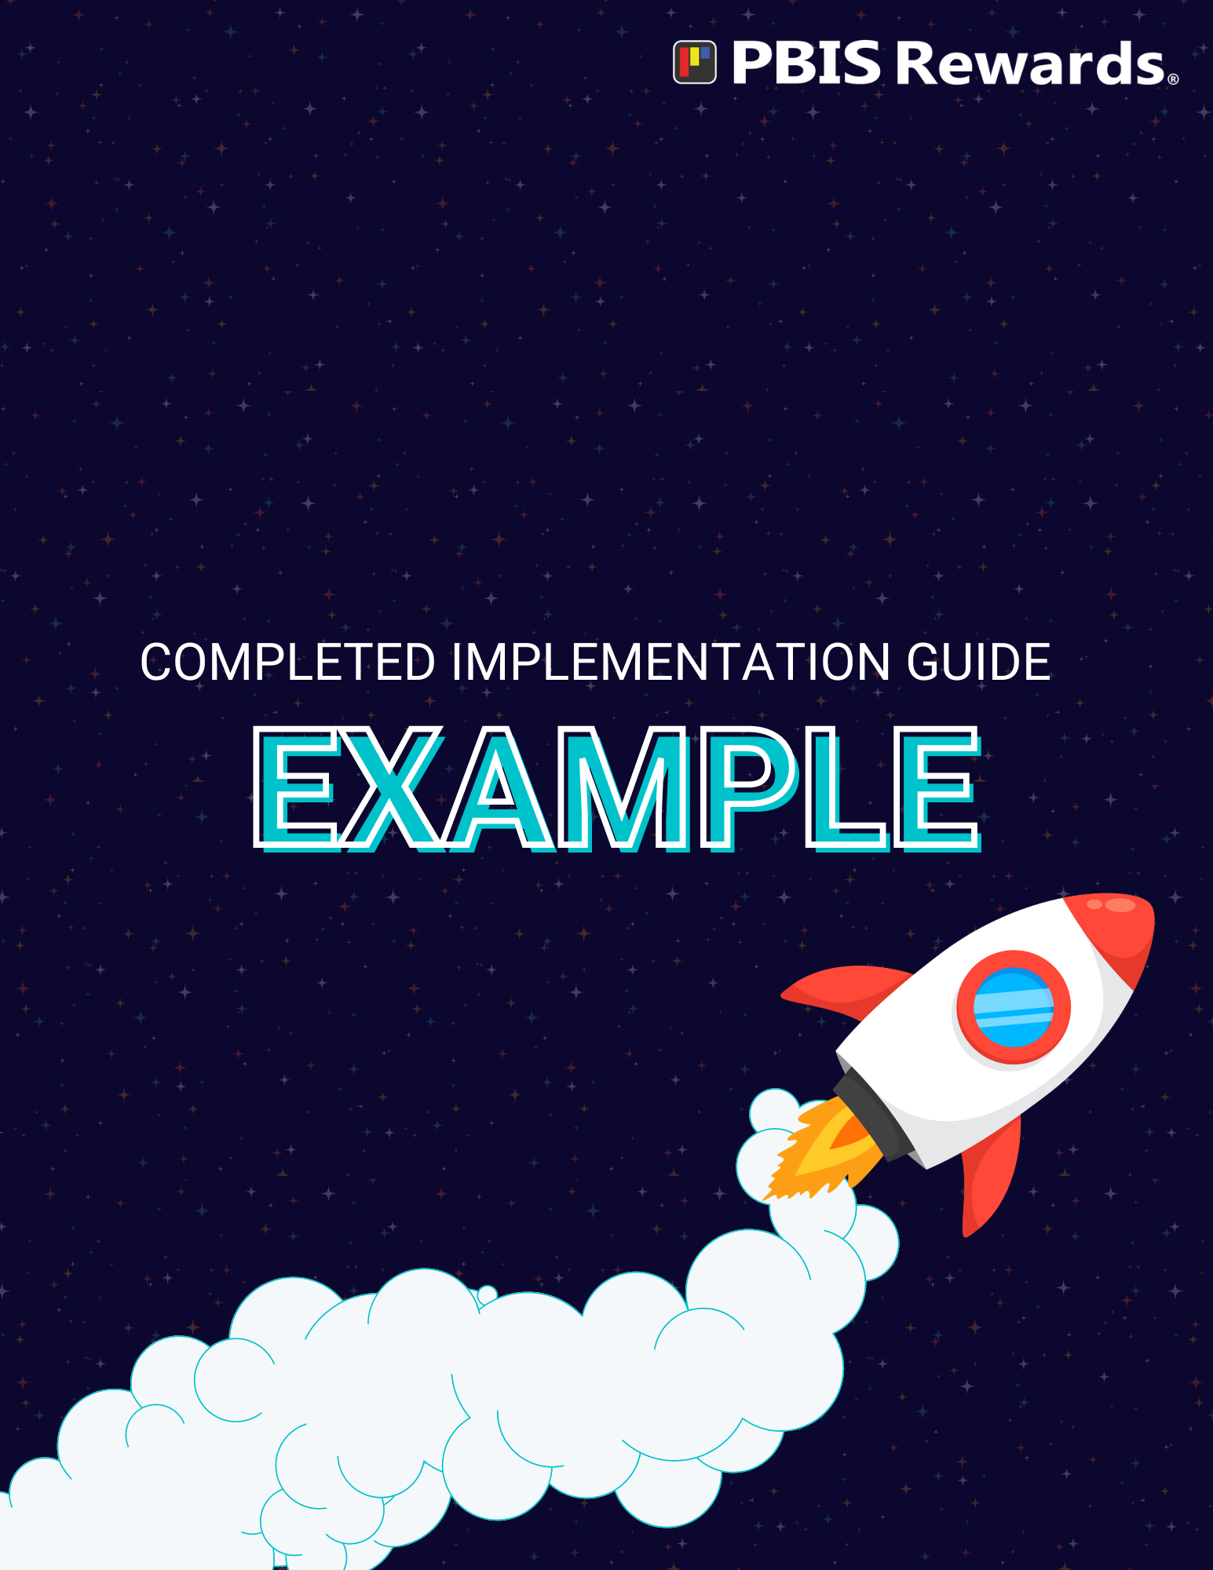

PBIS Leadership Team Info
Checkpoints to Get Started  Prerequisites before you jump into PBIS Rewards planning. | - PBIS Leadership Team in place  - School-Wide Expectations (Respect, Responsible, Safe)  - Behavior Matrix in place  - Training on PBIS Foundations to Staff  - Approval from district office
PBIS Leadership Team Members  - Who is leading the team?  - Do we have a cross-sampling of staff?  - Do we want parents or students to serve on the team? | Position | Name of Staff Member
 | Team Leader | Heather Brown (student services)
 | Admin. Team Member | Sherrie Hunt (admin)
 | Teacher | Chris Blevins (core classes)
 | Teacher | Katie Cook (core classes)
 | Teacher | Jamie Calbreath (electives)
 | Staff | Sharon Triplett (instructional support)
 | Staff | Haley Smith (Career Development/CTE)
 | Student Rep? | * Revisit later? Possibly Riley Bingman?
 | Parent Rep? | Maryann Gambill (Katie Cook will contact to ask)
Implementation Schedule  Do you have a plan for rolling out PBIS and PBIS Rewards to all your stakeholders? | Topics |  |  | Proposed Date
 | Pre-planning meeting with PBIS Leadership Team for roll-out |  |  | June 17th at 9am in library  July 15th 2pm in library  * Will we need to meet again before back-to-school workdays begin?
 | Telling the staff about PBIS Rewards (Communication plan!) |  |  | - Teaser video at Welcome Back Faculty Meeting  - Training during round-robin PD during August 14 workday
 | Faculty Meeting for Staff Buy-In |  |  | August 15 PD at 1pm  (PTO will serve lunch and cookies; Chris will get with PTO to organize; Sherrie/Heather/Jamie will work on PD Agenda)
 | Communication to Auxiliary Staff |  |  | Heather/Sherrie/Sharon will meet with all aux staff August 16 at 8:30am
 | First day to roll out for school-wide implementation |  |  | - Begin Teacher Rewards during initial PD (teaser video and round robin session)  - Student roll out on August 22 – first day of school
 | Student Assembly/Information session |  |  | August 26 (first Friday back) – PBIS Pep Rally (giving away points, announce a 1st quarter competition? Grade-level points to see who get’s the most points or least referrals?)
 | Parent/Community Roll-out |  |  | Have info table at Family Night (August 15 5-7pm)  Send additional info home via phone (all-call) and social media
PBIS Leadership Team  Meeting Schedule  Setting regular meetings to discuss implementation and data is a priority for successful implementation. | Monthly Meeting | Tentative Meeting Date |  |  | Data to Guide  Decision-Making
 | July | - July 15 @ 2pm |  |  | - Looking at past 3 years referral data to determine areas of need
 | Aug | - August 13
 | Sept | - Sept 12
 | Oct | - Oct 1o |  |  | - Looking at Q1 data  - Plan for reteaching after fall break
 | Nov | - Nov 14 |  |  | - Plan for reteaching after Thanksgiving break
 | Dec | - Dec 12
 | Jan | - Jan 9 |  |  | - Plan for reteaching after winter break
 | Feb | - Feb 13
 | Mar | - Mar 13 in office conference room
 | Apr | - Apr 20 |  |  | - Plan for reteaching after spring break
 | May | - May 15
 | June | - June 12
Notes |  |  | Reflections
All Meetings begin at 3pm in library unless otherwise noted.

- PBIS Leadership Team is built with staff representation
- PBIS Leadership Team Leader/Coach is a staff member, not Admin.
- Implementation plan for staff is fully planned
- Student and Family Roll Out planned

Rewarding Points

The number of points awarded to students daily will ultimately determine your school’s economy for redeeming.

Setting a daily point goal for classroom and support staff will help keep the fidelity of your economy in place so everyone can participate in your chosen redeeming option equitably.
Are we setting a Daily Point Goal for staff and students? | Staff |  |  |  | Students
 | Yes No |  |  |  | Yes No
What will the Daily Goal Point be?  Support staff should typically have a goal of 50% of classroom staff. Students typically have a goal of 20% of a classroom staff goal. | Classroom  Staff  (Frequent users such as teachers and teacher assistants who have regular interaction with students) | Support  Staff  (Moderate users such as administrators or school counselors who may have less frequent interactions to students) |  |  | Students
 | BOY – 80  MOY – 60  EOY - Revisit at MOY? | BOY – 40  MOY – 30  EOY - |  |  | BOY – 16  MOY – 12  EOY -
What will be your communication plan for each group? | Staff |  |  | Students
 | - Communicate DPG during Aug 14 round robin PD.  - Provide examples for helping staff develop habits to meet DPG (identify times and areas, etc to specifically look for point opportunities)  - Explain Star Rewards |  |  | - Include student DPG information in Back to School Blitz during first week
Progress Monitoring  Who is going to be responsible for checking on the progress of DPG for staff?  How will this data be shared? (With PBIS Leadership Team and all staff) | - Heather will check DPG progress via PBIS Rewards Reports every Friday morning and send a weekly update to staff as a percentage (“73% of staff met DPG goal this week”)  - Perfect opportunity to offer an incentive to teachers (“If we can get to 80% in two weeks, we will buy staff pizza for lunch”)  - Heather will document staff that are not reaching DPG each week and continue to look for patterns. Staff will be offered extra PD and support to encourage meeting DPG
Notes |  |  | Reflections

- Daily Point Goals have been established for staff and students
- Daily Point Goals are monitored by PBIS Leadership Team member(s)
- Communication Plan established as Daily Point Goals are adjusted over time

Redeeming Ideas

There are many options to redeem points inside of PBIS Rewards.

Do NOT feel pressure to try them all at once. Explore your options and then pick the right one for YOUR SCHOOL to try first.

Options for Redeeming in PBIS Rewards
Raffles  - Only need 1 item to raffle  - Perfect for a limited budget  - Great for an assembly  - Donated items can be raffled off |  | Events  - Schools already have lot of events happening. This will allow easy crossover!  - 3 different ways to host events  - Can use for entire school or selected grade levels |  |  | Stores  - Inventory is monitored by system with email notifications  - Less pressure for teachers to purchase items out of their own pocket

Raffles
Will we use Raffles? | Yes |  |  | No
Do we want to start with a Redeem or Qualify raffle?  Redeem raffles require students to spend points to enter the raffle. The more points the student spends to enter, the better chance they have of winning.  Qualify raffles DO NOT cost the students any points to enter BUT they must have earned the number of points needed to participate. If the student qualifies then they will automatically have one entry in the raffle by using Auto Register. | Redeem |  |  | Qualify
 | - School will use Magazine Fundraiser proceeds to purchase one high-ticket item, 2 medium-ticket items, and 3 low-ticket items each quarter to raffle off  - Sharon will create and send survey to students to get prize ideas |  |  | - Possibly save for end of semester reward?  - Qualify for movie afternoon?
What item(s) will we raffle? | AirPods, LED lights, Squishmallows, Bluetooth speakers, candy, water bottles, school gear, privileges? (designated parking spot, pizza delivery, etc)
Where will we host the raffle?  In person during assembly, virtually, record it and share, privately, and announce winner? | Haley will screencast into classrooms on the afternoon of the raffles. Prizes will be kept and picked up from Student Services immediately following raffles.
When will we run the raffle? | Friday, October 14 @ 3pm
Who will manage the Raffle? | Haley and Jamie will be schoolwide raffle point people.
Notes |  |  | Reflections
* Need to decide on a dates for subsequent raffles
* Chris will make flyers/posters with raffle information (pictures of prizes, # of points per entry, raffle date and time) and hand around school. Posters will be up by first Friday of school (Aug 26).

- Select raffles to encourage engagement, then explore other redeeming options as the year progresses.
- What? Where? When? Who? for raffles
Redeeming Ideas

There are many options to redeem points inside of PBIS Rewards.

Do NOT feel pressure to try them all at once. Explore your options and then pick the right one for YOUR SCHOOL to try first.

Options for Redeeming in PBIS Rewards
Raffles  - Only need 1 item to raffle  - Perfect for a limited budget  - Great for an assembly |  | Events  - Schools already have lot of events happening. This will allow easy crossover!  - 3 different ways to host events  - Can use for entire school or selected grade levels |  |  |  | Stores  - Inventory is monitored by system with email notifications  - Less pressure for teachers to purchase items out of their own pocket

Events
Will we use Events? | Yes |  |  |  | No
What events do we currently have scheduled for this year or plan to schedule? | - Homecoming Events  - Winter Holiday goody bags for retirement community residents  - Spring Fling
Do we want to start with a Redeem, Qualify, or a Reward event?  Redeem: Students spend points to attend. This type of event will deduct points.  Qualify: Do not deduct points. Students qualify by earning a set number of points in a specified time. Points do not have to be saved up; PBIS Rewards will calculate a running total of points earned.  Reward: Attendees earn the specified number of points | Redeem |  |  | Qualify |  |  | Reward
 | - End of month reward events  - First will be “cheaper” since so close to beginning of school and we want most/all students there |  |  | * Plan an end-of-semester event |  |  | * Encourage teachers to use Reward events when students complete extra credit assignments/classroom duties/event after school/etc.
What is the first event we will host? | - PBIS Kick-off Tailgate  - Teachers will work to make sure most students are eligible so they know the fun in store!  - Food?  - Games: cornhole, ladder golf
Cost of event?  Redeem = Deduct points  Qualify = Student met goal over time  Reward = Earn points | - Redeem Event that will Cost 10 points (fewer since only 2 weeks into school)
Where will we host the event?  In person, virtually, etc.? | - Football practice field (Chris will check with Coach Simons to make sure all clear and that trash cans will be available)
When will we host the event? | - Friday, Sept 2 after 3rd lunch – end of day
Who will manage the event? | - Heather and Chris will organize food  - Katie and Jamie will organize games  - Sharon and Haley will “advertise”  - Teachers with all students attending or 4th period planning will supervise event
Notes |  |  | Reflections

- Select events to encourage engagement, then explore other redeeming options as the year progresses.
- What? Where? When? Who? for events
Redeeming Ideas

There are many options to redeem points inside of PBIS Rewards.

Do NOT feel pressure to try them all at once. Explore your options and then pick the right one for YOUR SCHOOL to try first.

Options for Redeeming in PBIS Rewards
Raffles  - Only need 1 item to raffle  - Perfect for a limited budget  - Great for an assembly |  | Events  - Schools already have lot of events happening. This will allow easy crossover!  - 3 different ways to host events  - Can use for entire school or selected grade levels |  |  | Stores  - Inventory is monitored by system with email notifications  - Less pressure for teachers to purchase items out of their own pocket

Stores
Will we use Stores? | Yes |  |  | No
What will be the name of our School Store? | Tiger Trade
What categories will we use to divide up our store? | - Supplies  - Spirit Gear  - Privileges
Will we have digital and tangible options in our store?  Opportunities for experiences? | Tangible Items |  |  | Virtual Items
- Notebooks, pencils, pens, paper, earbuds, eraser caps
- T-shirts, water bottles, wristbands
 | Opportunities for Experiences
 | - Possibly in the future? (Special picnic area pass?)
Will we allow student purchasing?  All grades? Specific grades?  This can be changed in Settings menu. | - Students may stop by student services between classes to purchase
Where will we store the tangible items? | - Student Services closet
Who will manage the store?  Checking stock, organizing inventory, updating PBIS Rewards | - Ms. Rena will handle store purchases  - Heather and Sherrie will ensure store is stocked (biweekly checks or by notice from Ms. Rena)
When will the store be open?  Store hours can be set in the Settings menu. | - Store will be open before school and between classes (or if a teacher allows students to visit store during class)
How will you distribute tangible items to students? | - Ms. Rena will distribute items to student immediately upon purchase
Will we be utilizing Cashier Accounts for our store?  Who will give cashiers access? | - Not at this time. If Ms. Rena is unavailable, purchases can be made by any other available Student Services staff (all will have access)  - If Ms. Rena is not available, we will put on morning announcements that the Tiger Trade will have limited purchasing times (only before school and at lunch)
Notes |  |  | Reflections

- Select stores to encourage engagement, then explore other redeeming options as the year progresses.
- What? Where? When? How? Who? for stores

ID Cards
Did we order PBIS Rewards ID Cards?  Not sure? Find the ID Card contact in Settings under School Information. | YES |  | NO
Are we printing ID Cards for students to wear?  (If not ordered from PBIS Rewards)  Who is responsible for printing these? How will they be passed out? Will they be collected at the end of the day? | - Only if student loses their original
Are we utilizing printed ID Cards/QR Codes anywhere else?  (Various sizes available in PBIS Rewards)  Technology, folders, agenda books, desks, lockers, etc. | - Desk labels offered for teacher who assign seats  - Ask teachers to include printed QR code rosters in their emergency lesson plans and sub folders
What is the process to issue a NEW/REPLACEMENT ID Card?  Do you print off a paper ID Card? Have students purchase a new one from school store, etc. | - Replacement cards will be 10 points at the Tiger Trade  - Ms. Rena will handle purchasing and then submit the need to reprint to Heather via email
Notes |  | Reflections

- Determine if students will wear ID badges or if ID Badges/QR Codes will be placed in other locations for use.
- Complete the process for replacing ID Badges

Teacher Buy-In

Teacher Rewards in PBIS Rewards System
Will we use Teacher Rewards this year? | YES |  | NO
When will we roll out Teacher Rewards to the staff? | - During round robin PD on Aug 14
Since Teacher Rewards applies to ALL STAFF, what is the plan to roll out to non-classroom staff?  Bus drivers, cafeteria workers, custodians, secretaries, etc. | - During Aux staff meeting and training on Aug 16  - Follow up with an email explanation  - Offer a make-up meeting for anyone who was unavailable
What items will the teachers/staff be able to redeem points for? | - Auction at end of each semester (Haley will send google form to staff for gift ideas)  - Ask Booster club to donate some spirit gear for teachers to buy
Who will be the Admin. that will approve points in Teacher Rewards? | - Heather and Sherrie

General Teacher Buy-In Planning
What will be the first step to engage staff with PBIS Rewards? | - Handing out teacher rewards during round robin  - Issuing a DPG “challenge” for teachers (“If we have 50% meeting DPG by the end of ____ we will have cake in the breakroom”
What resources and topics will we share with staff? | Topics |  | Resources
 | - Goals for PBIS – give data for last 3 years discipline referrals  - Importance of consistency and staff buy-in |  | - Send email with PBIS Rewards Flight Course resources and remind staff to check their email for mini-PD from PBIS Rewards
What will the agenda be for professional development/training? | - PBIS Foundations training  - Introducing PBIS Rewards  - Time to plan (instances/time that staff plan to look out
Who will lead the PD? | - Heather and Sherrie
When will the PD be offered?  How will it be offered?  (In-person, virtually) | - August 14 during round robin (small group) PD  - Library
What resources do you need to create? | - Email to send after with links to resources on PBIS Rewards support site  - Printed handouts? Heather will look through and make the call
How do we celebrate teachers using PBIS Rewards with fidelity? | - Teacher Rewards  - Special raffle for teachers who meet DPG challenge?
What data will we share with staff regularly? | - Referral data and DPG data  - With referrals, share identified problem areas/times
What additional training will your PBIS Leadership Team, Staff, or Admin. need to be successful this year? | - Check out PBIS Rewards training calendar for additional trainings/workshops  - Identify trainings for Leadership Team/Admin and Staff (send out opportunities/ideas to staff via email)
Notes |  | Reflections

- Will we use Teacher Rewards?
- Roll out plan for all staff members completed
- Admin. for Teacher Rewards has been established
- Staff members have options to redeem points earned

Final Reflections
What is your #1 goal to accomplish this year? | - We will have 75% of our school meeting their Daily Point Goal by the end of the school year.
What are your three next steps to prepare for this goal before school starts? | 1. | Review Foundations Training slideshow (from PBIS Rewards) and tailor to our needs
 | 2. | Prepare teaser video for our Back to School faculty meeting (include some facts and some humor!)
 | 3. | Organize resources for staff and further PD to support

Advanced Referral System is a paid add-on
with the PBIS Rewards System.

If your school has this feature enabled, use the next pages to continue your planning.

ARS

Advanced Referral System is a paid add-on with the PBIS Rewards System.
If your school has this feature enabled, use this table to continue your planning.

Check YES or No for the following questions | YES |  | NO

Will your school use Major referrals?

Will your school use Minor referrals?

Will you rename Major/Minor referrals in PBIS Rewards?
Possible Change:
Major à ODR (Office Discipline Referral)
or Referral
*New Names if Changing | Major = |  | Minor =
Have you differentiated between Major and Minor behaviors? | (See districtwide discipline flowchart)
Identify the differences between a Major and a Minor behavior that will be shared with staff. | Major  Behaviors |  | Minor  Behaviors
 | - Fighting  - Bullying  - Tobacco & Weapons  - Overt disrespect (cursing at a staff member, etc)  - Certain technology infractions (inappropriate websites, cyber bullying, etc)  * Print flowchart for staff |  | - Minor disrespect (cursing in general, defiance, etc)  - Repeated unpreparedness  - Certain technology infractions (playing games during class, cell phone out during class)

Will staff submit Major referrals?

Will staff submit Minor referrals?
Will you notify Admin. for Minor referrals?  (If utilizing) | Upon a third minor referral, students will use checkboxes within ARS to submit as a major referral

Will ALL staff have viewing rights of ALL Minor referrals?

Have you aligned Major Referrals to state data requirements?

Customization Options for Major & Minor Referrals

Have you reviewed Customizations for Major and/or Minor Referrals?

Complete the table below to make the ARS System work for YOUR school
 | Major |  | Minor
Locations | - Classroom  - Bathroom  - Hallway  - Common Areas  - Off-Campus |  | - Classroom  - Bathroom  - Hallway  - Common Areas  - Off-Campus
Problem Behaviors | - Fighting  - Bullying  - Tobacco/Vaping  - Weapon  - Overt Disrespect/Defiance  - Vandalism  - Academic Dishonesty  - Major Technology Infraction  - Repeated Minor Referrals |  | - Disrespect  - Repeated Unpreparedness  - Tardy  - Minor Technology Infraction
Redirections | - Take a break  - Proximity control  - Student Conference  - Counselor visit  - Parent phone call  - Change in seating  - Assignment modification |  | - Take a break  - Proximity control  - Student Conference  - Counselor visit  - Parent phone call  - Change in seating  - Assignment modification
Possible Motivations | - Obtain Peer attention  - Avoid peer attention  - Obtain Adult attention  - Avoid adult attention  - Obtain Item/Activity  - Avoid task or activity |  | - Obtain Peer attention  - Avoid peer attention  - Obtain Adult attention  - Avoid adult attention  - Obtain Item/Activity  - Avoid task or activity
Admin. Action/Response | - Loss in privilege  - Time in office  - Conference with student  - Counselor small group  - Campus security report/referral to SRO  - Parent phone call  - Act of apology  - In School Suspension  - Out of School Suspension  - Detention |  | - Loss in privilege  - Time in office  - Conference with student  - Counselor small group  - Campus security report/referral to SRO  - Parent phone call  - Act of apology  - In School Suspension  - Out of School Suspension  - Detention

Have you created a Communication Plan for the use of ARS for staff?
Notes |  | Reflections

- ARS Settings have been customized using current school referral form as template
- Determine what forms will be used by staff: Major and/or Minor
- Staff understands how to complete forms

